01/16/2023

In sum, you should no longer be confused with which-is-which/who-is-who. Using a non-existing or newly created fake-name (no such dir-mnt-point in the file sys) is a case that you may want to use but maybe only when both side have the same dir-name as the mnt point.

Starting with showing off the 2 dirs/files to be used –

>ls /home/jxz008/my_slinks/top_dir /s_links_under_root/top_dir

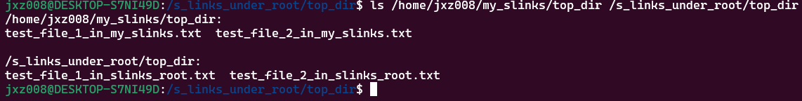

Relationship/syntax:

>**sudo ln -s** original_or_will_be_mapped_and_used the_faked_slink_or_from_here_u_can_work_on_the_real_mapped_from_place

In short:

>ln –s real fake

>ln –s src dest

It’s not counter-intuitive, but a natural order of from->slink/mount->to

You are slink/mount the real-point to your fake-point

You will be using the fake-point (after the mapping), instead of the real-point

If we want to mapped our file of /home/jxz008/my_slinks/top_dir to your /s_link_root…, then –

>sudo ln -s /home/jxz008/my_slinks/top_dir /s_links_under_root/top_dir

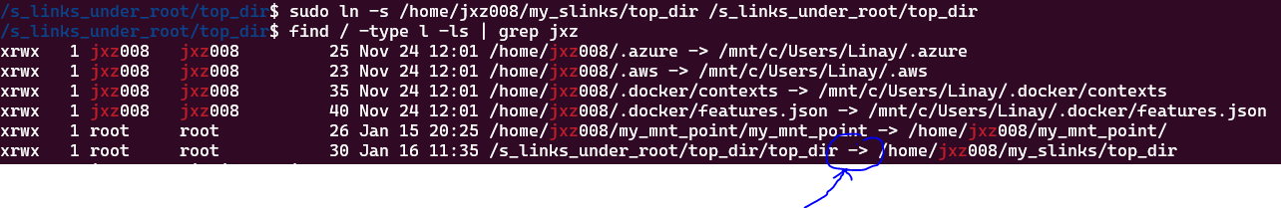

Arrow -> attaching the the last-dir of real-path to the fake-point/path, with that arrow-direction of real-full-path from

The same top_dir name a bit confusing tough

Run

> ls -ltra /home/jxz008/my_slinks/top_dir /s_links_under_root/top_dir

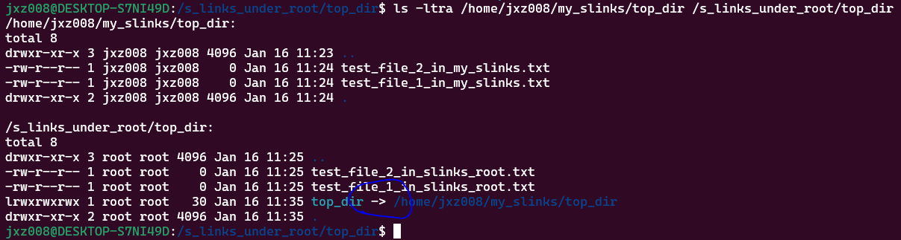

NB: The slink type may not be exactly like normal dir/file, e.g., you must navi to that dir first in order to view its content

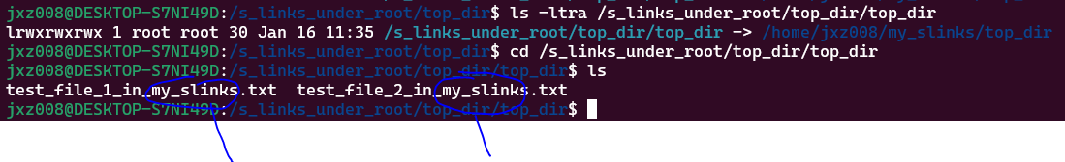

BTW – you edit your file from your slink-dir, it will be synced in your real place!

How to create a slink with s-name (e.g., named_slink_1) and this s-name will be kind of replacing the link-point (of the from-side)?

> sudo ln -s /home/jxz008/my_slinks/top_dir /s_links_under_root/top_dir/named_slink_1

In effect, named_slink_1 will replace - /home/jxz008/my_slinks/top_dir, and you will have –

>ls /s_links_under_root/top_dir/named_slink_1

Which seems to be less confusing than –

>ls /s_links_under_root/top_dir/top_dir



>readlink works for real or fake name, however, fake one is still less confusing

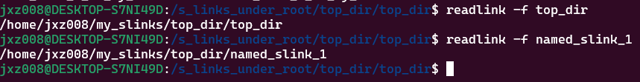

In short, the fake-name approach will be explicitly using that fake-name (which is not a dir in the source) on the dest-side and dest-side only. While the no introduced fake-name approach, will implicitly borrow the name of the last-level dir as the mount-point!

The explicit fake-name vs implicit default of last-dir of src is the either-or case, you must decide and choose one or the other!

NB: In our case that we have used the same-name top-dir for both side, if they are not the same, maybe the ‘implicit’ no newly introduced fake-dir-point-name would be better and less confusing, because you will see the real and existing dir-name from the src-side mapped in your dest-side!

e.g., -



>cd to your dest dir and then use name only



Above, you are facing the same issue of giving a new fake-name vs re-use the name of last-level dir as - top_dir_jxz_home

Dig into it, if not introducing a new fake-name layer, and how about re-use the last dir of dest (NB: not the src). Meaning and the last-dir of src will be mapped to be under the last dir of dest as –

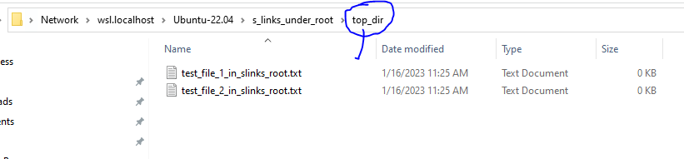

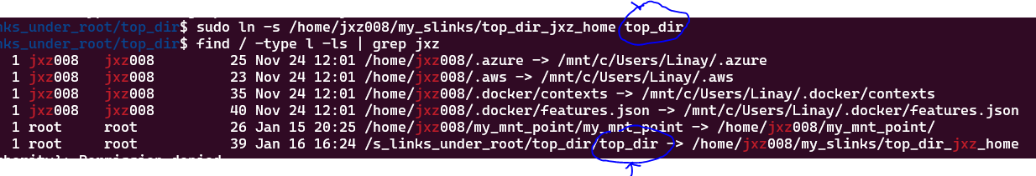

See, not working! “top_dir” cannot be ‘emerged’ as expected, it will be a new ‘layer’ created!

If not introducing any new fake-name, then the last-dir name of the src will be picked as –

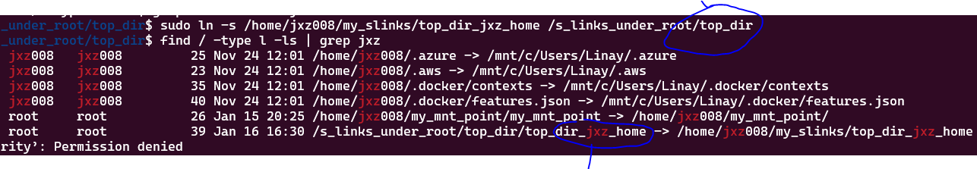

In short, there is no way to be mapped with the content of dir-top_dir_jxz_home without keeping that dir under the tree of dest?

In the meantime, the last dir has been used as the slink name, so you can do –

sudo unlink top_dir_jxz_home

It solid clear now, an extra slink-dir-layer must be introduced one way or another, re-using the dir-name of the src can tell you exactly where is the mapped from. There are cases, you’d better create/use another name for this mnt-point, e.g., the variable mnt-point for jdk version switch